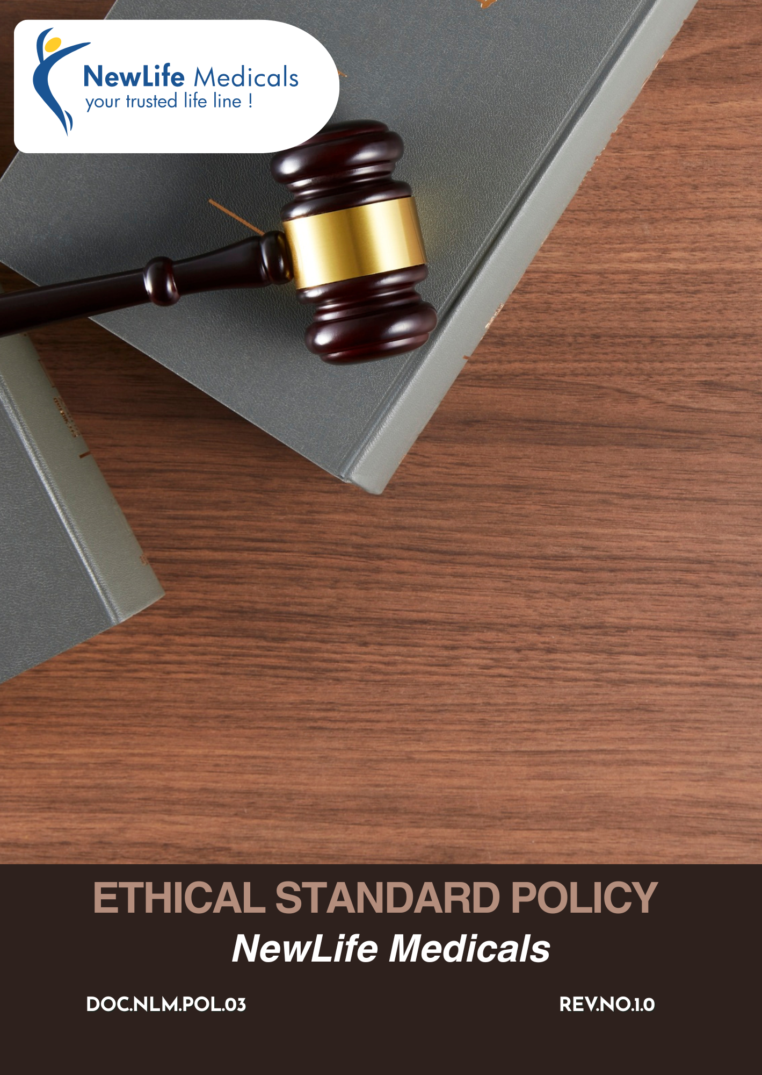

Table of Contents
Introduction 3
Objectives 3
Scope 3
Key Business Ethics Areas 4
Qualitative Targets 4
Quantitative Targets 8
Code of Ethics 10
Governance & Responsibility of this policy 13
Reporting 15
Enforcement Actions for Policy Violations 15
Continuous Improvement & Monitoring 16
Policy Alignment with SDGs 16
Review Mechanism 17
Employee Acknowledgement Form 18

Introduction
The Ethical Standard Policy of NewLife Medicals defines the principles, standards, and expectations that guide ethical behavior and responsible decision-making across the organization. It serves as a foundational framework to ensure that all business activities are conducted with integrity, transparency, and accountability, in compliance with applicable laws and industry standards.
The policy addresses key ethical risk areas including anti-bribery and corruption, fraud prevention, conflicts of interest, fair competition, information security and confidentiality, anti-money laundering, ethical marketing, and responsible third-party management. It outlines clear responsibilities, reporting mechanisms, and enforcement actions to ensure effective implementation and oversight.

Objectives
The objectives of the Ethical Standard Policy at NewLife Medicals are to:
- Establish clear ethical principles and standards to guide decision-making and behavior across all business activities.
- Promote a culture of integrity, transparency, accountability, and fairness at every level of the organization.
- Ensure compliance with applicable laws, regulations, and industry standards governing pharmaceutical and healthcare operations.
- Prevent bribery, corruption, fraud, conflicts of interest, and other unethical practices
- Protect confidential information, intellectual property, and personal data of employees, customers, and business partners.

Scope
This Policy applies to all operations of NewLife Medicals, including its offices, warehouses, distribution activities, and global sourcing and supply chain operations. It is applicable to all employees, management, contract workers, business associates, and stakeholders, whether internal or external, working on behalf of the Company.
Sr No | Group | Entity Name | Types | Address
1. | NewLife Medicals | NewLife Medicals Pvt Ltd | Offices | 1020 & 1021, 10th Floor, Maple Trade Center, Near Surdhara Circle, Thaltej, Ahmedabad – 380059
2. | NewLife Medicals | NewLife Medicals (USA), Inc | Offices | 146 Donmoor CT, Garner, North Carolina 27529, USA
3. | NewLife Medicals | NewLife Biopharma Limited | Offices | SKY Business Centre, Office 12, Unit 9a, Plato Business Park, Damastown, Dublin 15, Ireland D15 PA4C

Key Business Ethics Areas
- Prohibition of bribery, facilitation payments, kickbacks, and any improper advantage in business or regulatory dealings.
- Prevention of falsification of records, misrepresentation, financial manipulation, and misuse of company assets.
- Ensuring impartial decision-making free from personal, financial, or relational influence.
- Protection of client data, regulatory dossiers, pricing information, and proprietary business documents.
- Prevention of unlawful financial transactions and ensuring transparent, traceable payment practices.
- Responsible, accurate, and compliant representation of products and services without misleading claims.

Qualitative Targets
- Corruption and Bribery
- We are committed to rejecting gifts, hospitality, or incentives that may influence decision-making
- We are committed to maintaining a zero-tolerance approach toward bribery and corruption across all sourcing, clinical trial supply, export, and regulatory activities to protect patient safety, regulatory integrity, and global business credibility.
- We aim to conduct all transactions with transparency, fairness, and accountability, ensuring that no employee, agent, distributor, or third-party representative offers, gives, or receives any improper advantage to secure business benefits.
- We commit to implementing strong internal controls, approval mechanisms, and documentation procedures to prevent unethical payments, facilitation payments, or kickbacks, particularly in high-risk areas such as international procurement and regulatory submissions.
- We strive to provide regular ethics and anti-corruption awareness training to employees to help them identify and prevent bribery risks.
- We maintain strict due diligence processes for suppliers, logistics partners, and intermediaries to ensure alignment with anti-corruption laws such as the Prevention of Corruption Act (India) and applicable international regulations.
- We continue to enhance transparency in gifts, hospitality, sponsorships, donations, and interactions with government officials and customers
- We encourage employees to report suspected unethical conduct through confidential reporting channels, ensuring protection against retaliation.
- To strengthen governance and minimize ethical and compliance risks, we will implement robust internal controls such as structured authorization workflows, defined role segregation, and formal conflict-of-interest declarations.
- Fraud Prevention
- We are committed to upholding the highest standards of integrity and accuracy in all financial activities, ensuring that no form of fraud, falsification of documents, or manipulation of records is tolerated within the organization.
- We aim to establish and maintain robust internal control systems, segregation of duties, and multi-level approval mechanisms to prevent fraudulent activities in procurement, clinical supply distribution, export documentation, invoicing, and financial reporting.
- We commit to ensuring complete transparency and traceability in product sourcing and documentation, particularly in RLD sourcing, API exports, and named patient supply services, to eliminate risks of duplicate invoicing, or false certifications.
- We strive to conduct periodic internal audits and risk-based assessments to proactively identify vulnerabilities in supply chain transactions, customs documentation, regulatory filings, and vendor payments before they escalate into material fraud risks.
- We maintain strict verification and due diligence procedures for suppliers, distributors, and third-party intermediaries to prevent fraudulent misrepresentation of licenses, product authenticity, or compliance certifications.
- We will conduct regular training programs for employees on fraud prevention to enhance awareness across the organization.
- Conflict of Interest
- We are committed to ensuring that all business decisions are made objectively and in the best interest of NewLife Medicals, without undue personal, financial, or relational influence.
- We aim to prevent situations where personal relationships with suppliers, customers, regulators, or competitors may compromise impartial judgment, particularly in procurement, contract negotiations, and regulatory dealings.
- A structured conflict of interest framework will be implemented, including regular disclosure requirements, defined oversight roles, and formal documentation of corrective actions.
- We are committed to maintaining an open and transparent environment where conflicts are assessed objectively and managed to safeguard the Company’s integrity and interests.
- We prohibit the use of company position, confidential information, or business opportunities for personal gain, including engaging in competing activities or influencing vendor selection for personal benefit.
- We promote awareness and periodic guidance on identifying conflict-of-interest risks, especially in high-risk functions such as sourcing of RLDs, API procurement, distributor appointments, and international partnerships.
- We aim to ensure that all employees proactively disclose actual, potential, or perceived conflicts of interest that may affect business decisions.
- Information Security and Confidentiality
- We are committed to safeguarding all confidential, and sensitive information, , against unauthorized access, disclosure, or misuse.
- We aim to implement robust information security controls, including restricted access, password protection, secure data storage, and controlled document sharing, to maintain the integrity and confidentiality of business-critical information.
- We require all employees, and third-party partners to maintain strict confidentiality obligations, particularly when handling comparator drug sourcing data, named patient supply records, export documentation, and regulatory submissions.
- We prohibit the unauthorized sharing, copying, or transmission of company or client information, whether verbally, electronically, or in printed form, including through personal devices or unsecured communication channels.
- We aim to implement robust information security controls, including role-based access mechanisms, firewall protection, restricted system access, strong password protocols, secure data storage, and controlled document sharing, to ensure the integrity and confidentiality of business-critical information.
- We commit to ensuring compliance with applicable data protection and privacy regulations, especially in relation to international clients, cross-border transactions, and sensitive healthcare-related information.
- We promote regular awareness and training programs on cybersecurity risks and data protection practices, enabling employees to identify threats such as phishing, data breaches, or unauthorized system access and take preventive action.
- Anti-Money Laundering
- We are committed to conducting business only with legitimate clients, suppliers, and partners, ensuring that all funds received or paid are derived from lawful and transparent sources.
- A formal AML framework will be established to ensure effective due diligence, ongoing transaction oversight, clear escalation mechanisms, and thorough documentation.
- We uphold financial integrity by maintaining transparent processes, ensuring transaction traceability, and enforcing strict authorization and record-keeping controls across all financial activities.
- We aim to implement risk-based customer and supplier due diligence procedures, including verification of legal status, beneficial ownership, regulatory licenses, and banking credentials prior to onboarding.
- We commit to maintaining accurate, complete, and transparent financial records, ensuring that all invoices, contracts, and payment trails are properly documented and auditable.
- We maintain strict compliance with applicable anti-money laundering laws and financial regulations, including Indian statutory requirements and relevant international trade compliance standards.
- We aim to provide periodic training and awareness programs to employees involved in finance, procurement, export, and regulatory coordination, enabling them to identify and report potential money laundering risks.

- Ethical Marketing and Third-Party Conduct
- We are committed to ensuring that all marketing, promotional, and business development activities are accurate, evidence-based, and compliant with applicable pharmaceutical and trade regulations, avoiding misleading claims, exaggerated representations, or unsubstantiated product comparisons.
- We aim to promote our services such as comparator sourcing, API supply, and clinical trial support through transparent and responsible communication, ensuring that all information shared with clients reflects verified data and approved documentation.
- We commit to conducting integrity-based screening and risk assessments prior to engaging third parties, particularly in high-risk international markets and regulatory interactions.

Quantitative Targets
- Corruption and Bribery
- We continue to maintain zero confirmed cases of bribery, facilitation payments, or improper influence across all operations each year.
- We aim to achieve 100% completion of annual business ethics and anti-bribery & anti-corruption training for all employees by 2029, against the 2023 baseline year.
- We aim to ensure that 100% of contracts with agents, distributors, consultants, intermediaries, and key suppliers include anti-bribery, anti-corruption, and ethical conduct clauses by 2029, against the 2023 baseline year.
- We aim to record, review, and approve 100% of gifts, hospitality, sponsorships, donations, and charitable contributions through approved internal registers on an annual basis by 2029.
- We aim to maintain 100% compliance with applicable anti-bribery and anti-corruption laws, internal policies, and procedures across all business activities by 2029.
- Fraud Prevention
- We continue to maintain zero tolerance for falsified records, data manipulation, or misuse of company assets annually.
- We aim to ensure 100% of financial, quality, laboratory, manufacturing, and operational records are subject to internal audits or reviews as per approved audit plans by 2029, against the 2023 baseline year.
- We commit to investigating 100% of reported fraud, misconduct, or financial irregularity allegations within 30 calendar days by 2026, against the 2023 baseline year.
- We aim to conduct fraud-risk assessments at 100% of operational sites at least once every two calendar years.
- We commit to delivering mandatory training on fraud prevention, internal controls, and ethical business practices to all employees, targeting 100% coverage by 2029 compared to the 2023 baseline year.
- Conflict of Interest
- We aim to maintain zero conflicts of interest annually.
- We aim to achieve 100% annual conflict-of-interest declarations from all employees by 2029, against the 2023 baseline year.
- We aim to ensure 100% of declared conflicts are formally documented, assessed, and managed through appropriate mitigation or control plans.
- We aim to provide conflict-of-interest awareness and guidance training to 100% of employees by 2029, against the 2023 baseline year.
- Information Security and Confidentiality
- We continue to maintain zero critical data breaches caused by policy non-compliance annually.
- We aim to ensure 100% of employees receive annual information-security and data-privacy training by 2029, against the 2023 baseline year.
- We aim to implement access controls, encryption, and cybersecurity safeguards on at least 80% of critical IT systems and devices by 2029, against the 2023 baseline year.
- We aim to respond to at least 80% of reported data-security incidents within 72 hours of identification.
- We aim to implement multi-factor authentication across 100% of digital platforms by 2028, using 2022 as the baseline year.
- Anti-Money Laundering (AML)
- We aim to maintain zero cases filed against the AML Compliance annually.
- We aim to screen 100% of customers, distributors, suppliers, and third-party business partners prior to onboarding by 2029, against the 2023 baseline year.
- We aim to re-screen at least 70% of high-risk partners annually to identify emerging AML or financial-crime risks by 2029, against the 2023 baseline year.
- We continue to ensure 100% of financial transactions are processed through traceable and approved banking channels.
- We aim to ensure 100% of suspicious transactions are escalated, reviewed, and reported in accordance with applicable regulatory requirements.
- We aim to ensure 100% of employee received the AML training by 2029 from baseline 2023.
- Ethical Marketing and Third-Party Management
- We aim to include ethics and compliance clauses in 100% of new and renewed third-party contracts by 2029 from 2023 as a baseline.
- We aim to close at least 90% of identified third-party ethics gaps within defined timelines by 2029, against the 2023 baseline year.
- We aim to provide ethics awareness communication or training to at least 70% of key suppliers and distributors by 2029, against the 2023 baseline year.

Code of Ethics
- Corruption and Bribery
Ethical Guideline: All business decisions must be made fairly and independently, without offering, giving, soliciting, or accepting bribes or improper advantages.
Example: A procurement employee is offered an expensive gift by a supplier during contract renewal discussions to influence the award decision. The employee refuses the gift, records the incident, and informs the Compliance team.
DO
- Do conduct business transparently and honestly.
- Do refuse and report any offer of bribes, kickbacks, or facilitation payments.
- Do record gifts, hospitality, sponsorships, and donations in approved registers.
- Do seek prior approval for interactions with government officials or healthcare professionals.
DON’TS
- Don’t offer or accept cash, gifts, favors, or benefits intended to influence decisions.
- Don’t use third parties to bypass legal or ethical requirements.
- Don’t disguise improper payments as “consulting” or “marketing” fees.
- Don’t ignore corruption red flags.
- Fraud Prevention and Financial Integrity
Ethical Guideline: All records and transactions must be accurate, complete, and supported by proper documentation.
Example: An employee notices incorrect expense claims submitted by a colleague. Instead of ignoring it, the employee reports the issue through the reporting mechanism.
DO
- Do maintain accurate financial, quality, and operational records.
- Do follow approval limits and internal control procedures.
- Do report suspect fraud or irregularities promptly.
- Do cooperate fully with audits and investigations.
DON’TS
- Don’t falsify or manipulate records or data.
- Don’t approve payments without proper evidence.
- Don’t misuse company assets for personal benefit.
- Don’t conceal errors or irregularities.
- Conflict of Interest
Ethical Guideline: Personal interests must not interfere with company decisions or responsibilities.
Example: An employee’s relative owns a logistics company bidding for a NewLife Medicals contract. The employee discloses the relationship and does not participate in the decision.
DO
- Do disclose actual or potential conflicts of interest.
- Do recuse yourself from conflicted decisions.
- Do seek guidance if unsure about a situation.
DON’TS
- Don’t award business to friends or relatives without disclosure.
- Don’t use insider information for personal gain.
- Don’t influence hiring or procurement for personal benefit.
- Information Security and Confidentiality
Ethical Guideline: Confidential and personal information must be protected from unauthorized access or misuse.
Example: An employee receives phishing email requesting login credentials. The employee does not click the link and reports it to IT immediately.
DO
- Do protect confidential, technical, and personal data.
- Do use strong passwords and approved IT systems.
- Do report data breaches or suspicious activity immediately.
DON’TS
- Don’t share passwords or sensitive information.
- Don’t store company data on unauthorized devices or apps.
- Don’t discuss confidential matters in public places.
- Anti-Money Laundering
Ethical Guideline: The Company must not be used for money laundering or illegal financial activities.
Example:A distributor requests payment through an unrelated third party. The finance team flags and escalates the request instead of processing it.
DO
- Do perform due diligence on customers and partners.
- Do use traceable and approved banking channels.
- Do report suspicious transactions promptly.
DON’TS
- Don’t accept large or unexplained cash payments.
- Don’t process transactions to avoid reporting thresholds.
- Don’t ignore sanctions or regulatory alerts.
- Ethical Marketing and Promotion
Ethical Guideline: Marketing and sales activities must be truthful, fair, and compliant with laws and regulations.
Example: A sales representative ensures promotional material is approved by Compliance and does not make unverified claims to healthcare professionals.
DO
- Do ensure marketing claims are accurate and supported by approved data.
- Do follow regulatory and compliance approval processes.
- Do compete fairly and ethically.
DON’TS
- Don’t exaggerate product benefits or hide risks.
- Don’t engage in price-fixing or unfair competition.
- Third-Party Conduct
Ethical Guideline: Third parties must adhere to the same ethical standards as NewLife Medicals.
Example: A supplier is found violating labor laws. The Company initiates corrective actions and may terminate the relationship if issues persist.
DO
- Do assess third-party ethics and compliance risks.
- Do include ethics clauses in contracts.
- Do monitor third-party conduct regularly.
DON’TS
- Don’t engage third parties to perform unethical acts.
- Don’t overlook repeated ethical violations.
- Don’t continue relationships with unresolved integrity risks.

Governance & Responsibility of this policy
Managing Director
- Provide overall leadership and set the “tone at the top” for ethical conduct and compliance.
- Ensure the Ethical Standard Policy is effectively implemented and integrated into business strategy and operations.
- Review key ethics risks, incident trends, and policy effectiveness at least annually.
- Approve significant updates to the Ethical Standard Policy and related governance frameworks.
Compliance Head
- Lead the implementation and day-to-day management of the Ethical Standard Policy.
- Develop procedures, controls, and guidance to support ethical conduct across functions.
- Conduct ethics risk assessments, coordinate training programs, and monitor compliance performance.
- Receive, assess, and investigate reported ethics concerns in a fair, confidential, and impartial manner.
- Escalate significant violations and investigation outcomes to senior management.
Department Heads
- Review policy regularly
- Ensure employees within their functions understand and comply with the Ethical Standard Policy.
- Integrate ethical considerations into operational decisions, procurement, and third-party engagements.
- Review and approve sensitive activities such as vendor selection, sponsorships, gifts, and interactions with healthcare professionals.
- Support employees who raise concerns and ensure corrective and preventive actions are implemented.
Human Resources
- Support policy implementation through onboarding, training, and awareness programs.
- Ensure ethical conduct is embedded in performance management and disciplinary processes.
- Maintain records related to policy acknowledgment, training completion, and disciplinary actions.

Information Technology Head
- Maintain secure IT systems, access controls, and data-protection mechanisms.
- Monitor cybersecurity risks and coordinate timely response to data-security incidents.
- Support training and awareness related to information security and data privacy obligations.
All Employees and Third Parties
- Understand and comply with the Ethical Standard Policy and applicable procedures.
- Follow the guidelines and acknowledge the violation outcomes
- Act with integrity, honesty, and accountability in all business activities.
- Disclose conflicts of interest and avoid participation in unethical practices.
- Promptly report suspected misconduct, violations, or unethical behavior without fear of retaliation.

Reporting
NewLife Medicals is committed to maintaining an open and transparent culture where ethical concerns can be raised without fear of retaliation. Employees, contractors, and business partners are encouraged to report any suspected violations of the Ethical Standards Policy, applicable laws, or company procedures, including issues related to bribery, fraud, conflicts of interest, data security, unethical practices, or third-party misconduct. Concerns may be reported to supervisors, Department Heads, Human Resources, or the Compliance/Ethics Officer, and may be submitted confidentially or anonymously where permitted by law. All reports are recorded and investigated promptly, fairly, and confidentially.

Enforcement Actions for Policy Violations
- Any breach of this policy will result in appropriate disciplinary action based on the severity, intent, impact, and frequency of the violation committed.
- Disciplinary measures may include verbal or written warnings formally documented in the employee’s personnel file for future reference and compliance tracking.
- Mandatory retraining sessions or structured corrective action plans may be required to address gaps in awareness, conduct, or internal control adherence.
- Temporary suspension of duties, decision-making authority, system access, or other organizational privileges may be imposed during investigation or review.
- Financial recovery proceedings may be initiated in cases involving proven financial loss, fraud, asset misappropriation, or intentional misuse of company resources.
- Termination of employment, contractual engagement, or business relationship may occur in cases involving serious misconduct, negligence, or repeated non-compliance.
- Legal proceedings, civil recovery measures, or regulatory reporting obligations may be initiated where violations contravene applicable laws or statutory requirements.
- Vendors, contractors, consultants, or business partners found in violation may face immediate contract termination, suspension, or permanent blacklisting from future engagements.
- Failure to report known violations, deliberate concealment of misconduct, retaliation against whistleblowers, or falsification of records will attract strict disciplinary consequences.
- All alleged violations will be investigated thoroughly, objectively, and confidentially, ensuring fair due process and unbiased decision-making before final disciplinary action.

Continuous Improvement & Monitoring
NewLife Medicals is committed to continuously strengthening its ethical framework through regular monitoring and improvement of its Ethical Standards Policy and related practices. The Company reviews ethics controls, procedures, and awareness programs to ensure compliance with applicable laws and industry best practices. Through internal audits, compliance assessments, and management reviews, the Company monitors adherence across operations and third-party engagements. Findings, reported incidents, and employee feedback are analyzed to identify risks and improvement areas, leading to enhanced policies, stronger controls, updated training, and improved communication to promote integrity and accountability.

Policy Alignment with SDGs

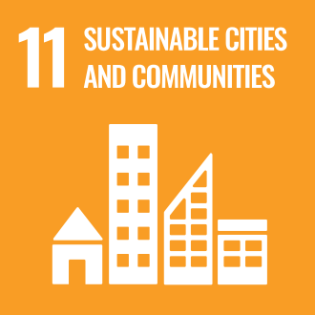
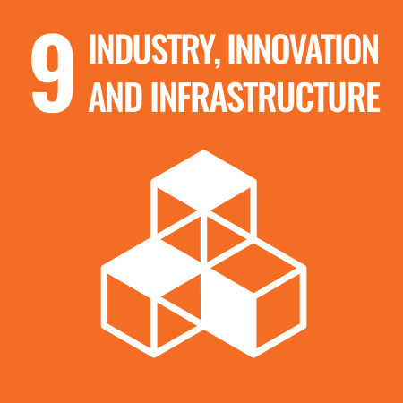

Review Mechanism
This Ethical Policy is reviewed on a regular basis to ensure it remains current, effective, and aligned with applicable laws, regulatory requirements, and organizational objectives. The review is conducted by the Compliance Head in coordination with the Compliance function and relevant department heads. A formal review is carried out at least once every year or earlier in the event of significant changes in legal requirements, business operations, organizational structure, or risk profile.
Effective Date: 01 January 2025
Last review date: 01 January 2026
Next review date: 01 January 2027
Revision number: 1.0

Approved by:
Managing Director

Employee Acknowledgement Form
I acknowledge that I have received, read, and understood the Company’s Ethical Standard Policy, including sections on corruption prevention, fraud control, conflicts of interest, information security, and anti–money laundering practices.
I understand that it is my responsibility to comply with the requirements described in this policy and to act with honesty, integrity, and transparency in all business activities. I agree to seek clarification whenever I am unsure about how the policy applies to my role and to report any suspected violation or unethical behavior through the company’s designated reporting channels, without fear of retaliation.
By signing below, I confirm my commitment to uphold the company’s ethical standards and contribute to a responsible and compliant workplace.
Department: ___________________________
Employee Name: ___________________________
Employee ID: ___________________________
Employee Signature: ___________________________
Date: ___________________________

